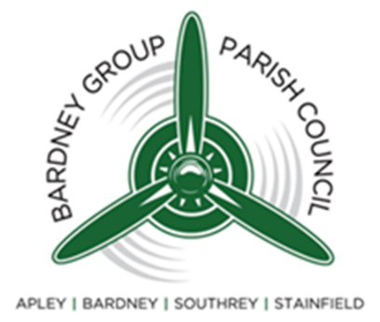 | Bardney Group Parish Council  Parish Office  c/o Village Hall  Bardney  LINCOLN  Lincolnshire  LN3 5SS

Grievance Procedure
Updated January 2026

Dealing with grievances informally
If you have a grievance or complaint about your work or someone you work with you should start by speaking with your manager wherever possible. You may be able to agree a solution informally between you.

Formal grievance
If the matter is serious or you wish to raise it formally you should put the grievance in writing to your manager. You should keep to the facts and avoid language that is insulting or abusive.
If your grievance is against your manager and you feel unable to approach them, you should raise it with the Chair of the Personnel and Review Committee.

Grievance hearing
The Chair of the Policy and Resource Committee will call you to a meeting, usually within 5 working days, to discuss your grievance. You have the right to be accompanied by a colleague or trade union representative.
After the meeting the* Chair of the Personnel and Review Committee will give you a decision in writing, usually within 24 hours.
If the manager needs more information before making a decision, they will inform you of this and the timescale.

Appeal
If you are unhappy with the decision on your grievance you can raise an appeal. You should tell your manager.
You will be invited to an appeal meeting, normally within 5 working days, with the *Chair of the Council. You have the right to be accompanied by a colleague or trade union representative.
After the meeting your manager will give you a decision, usually within 24 hours. The Appeal panel decision is final.

*At least one other member of the Council will be present at hearing and appeal meetings*

Adopted by Council: Date…………………………

Signed: ……………………………………………………………………………………….

Print Name……………………………………………………………………………………

